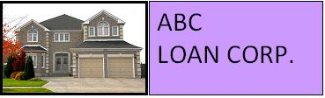

We offer 15-year fixed rate Jumbo loans.

15-Year Fixed-Rate Jumbo
This type of loan offers higher monthly payments, however you pay less interest over time and you build equity faster. This loan type is a good choice if you want to own your home sooner and can afford higher payments during this timeframe.

Jumbo loans have higher fees and rates due to the risk involved in loaning larger amounts of money. If, after an 8-year period, there are no late payments, the loan terms will be reduced by 1%.
Based on your down payment, credit rating, and processing fee options, the interest rate for 15 years is:

 | 2.5% Fee | 1.5% Fee | 0.5% Fee
Conventional | 5.75% | 5.95% | 6.15%
Non-conventional | 6.75% | 7.0% | 7.25%

Interest rates are subject to change. Please contact our loan officer for the latest rates.

1-800-ABC-LOAN

info@mymail.com

